PERSONAL DETAILS
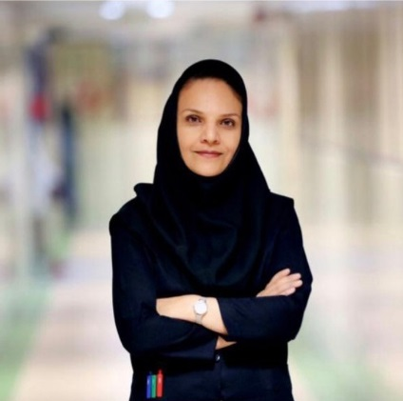 | Full Name | Azin Alizadehasl
 | Gender | Female
 | Designation | Medical doctor
 | Department | Cardio-oncology
 | Institution/Organization | Rajaei cardiovascular, medical and research center
 | Qualification | Professor
 | Area of Specialization | Echocardiography, Cardio-oncology
 | Sub Division | Cardiology
 | DOB | 31. july.1975
 | DOJ | 2007
 | Total Experience | 15 years
 | Mobile Number | +989122258582
 | Email | alizadeasl@gmail.com
About your Education, Experience and Academic achievements (200 words)

I participated in the university entrance exam in 1993 and was accepted into the medical school of Tabriz university of medical science and graduated as the 2nd ranked top student in 2000. Then I took the residency entrance exam in 2002 and was accepted into the cardiovascular disease residency. I finished four years of education and passed the board exam with the 10% top score. I have been employed as an assistant professor of the cardiology department of Tabriz university of medical science for five years and was training medical students and residents while I was researching. I decided to develop my education in the field of echocardiography and started an echocardiography fellowship at the Tehran university of medical science. After completing the two years of fellowship course, I joined at Rajaei cardiovascular medical and research center’s science committee as an associate professor. Since then, I am responsible for training fellows and cardiology residents. I completed a one-year observer ship of a cardio-oncology course in Canada and three echocardiography courses at the MD-Anderson and Methodist hospital in the USA. Then I established the first cardio-oncology department in Iran, and the first fellows in this field were attracted.

RESEARCH, INNOVATIONS AND EXTENSION
Question | Nos. | Question | Nos.
No. of Research Project Completed and On Going | 391 | Citation index in Scopus/ Web of Science or PubMed/ Indian Citation Index | 652
No. of Consultancy and Industries Sponsored Projects | 52 | No. of Books Published with ISBN  (Text, Reference, Chapters and Conference Proceedings) | 15
Total cost of the all Projects in USD/INR | 2000$ | No. of Patent Published and Under Process | 3
No. of Journals Published in SCI and SCIE index | 25 | No. of Editorial Appointments in Journals/ Conferences (Editor, Reviewer and Member) | 15
No. of Journals Published in Scopus, Web of Science and PubMed index | 62 | No of Countries Visited for research activities | 5
No. of Journals Published in Other index | 223 | No. of Research scholar Graduated | 550
No. of Conference Presentation | 120 | No. of Research scholar On Going | 60
Cumulative impact factor of the last 3 years |  | No. Invited Speaker/ Resource person | 500
H-index: Bibliometrics of the publications based on Scopus/ Web of Science. | 15 | No. of Research Conference/workshop Organized | 120
Total number of Collaborative activities for research: (Joint publication/Project) | 350 | Total number of awards and recognition received | 10
Number of functional MoUs with other universities/ industries/ corporate. | 6 | No. of Member of Professional Bodies: | 3
Areas of Research | Cardiology, cardiac imaging, echocardiography, cardio-oncology, cardiotoxicity
About your contribution towards the Research & Development, Innovations, and Extension Activities (200 words)

I've always been interested in investigation and learned research methodology from the beginning of medical school. During my cardiology residency and after being an assistant professor at Tabriz University of medical science, I have continued research seriously in the field of cardiology. Following my promotion to the Rajaei Heart Center as an associate professor, my research progressed more broadly in cardiac imaging and cardio-oncology. I also completed various cardio-oncology and echocardiography courses in North America. The rise of cancer survivorship and cancer treatments' impact on the cardiovascular system is a significant health problem in the world, so I founded the first specialized cardio-oncology center in the Middle East and established the region's first fellowship in the field to provide cutting-edge care and advance cardio-oncology science through research and education. Many fellows graduated from this center, helping and treating patients in different parts of Iran. Our department brings together a multidisciplinary cardiology, oncology, radiology, and radiotherapy team to provide comprehensive care for cancer patients with cardiovascular complications and collaborations with other institutions in Iran. During this time, I was the mentor of all the physicians who started working and researching in this field. Every month we offer training programs and workshops for physicians and nurses. We are also active in inventions in echocardiography and cardiac devices at this center. We aim to develop new treatment strategies and improve outcomes for cancer survivors and are proud to lead the way in this exciting and rapidly evolving field.

PERSONAL/ RESEARCH PROOFS, CATEGORY OF AWARD AND DECLARATION

Google scholar link  (Publication Proof) | https://scholar.google.com/citations?hl=en&user=6CoGZtcAAAAJ
Scopus link  (Publication Proof) | https://www.scopus.com/authid/detail.uri?authorId=35098104800
Linkedin link  (Publication Proof) | https://www.linkedin.com/in/azin-alizadehasl-md-facc-fase-387ba891/
Researchgate link  (Publication Proof) | https://www.researchgate.net/profile/Azin-Alizadehasl
Institute ID Link/Upload/Number  (Working Proof) | http://rhc.ac.ir/en  http://prof.rhc.ac.ir/alizadehasl/fa
Certificate Links/Upload/Number  (Education Proof of Last degree) | https://membersearch.irimc.org/member/profile?id=cb4b2567-45a0-4873-b168-653b9abe47d9
Passport/ Govt. ID Links/Upload/ Number (Age Proof) | ID no: 70  Passport no: E45605942
Personal website link | https://cardionco.com  https://en.wikipedia.org/wiki/Azin_Alizadehasl
Tick the Suitable award category | - Distinguished Scientist Award  - Young Scientist Award  - Life time achievement Award  - Outstanding scientist award  Women Research Award  - Best Researcher Award  - Best Innovation Award | - Best Faculty Award  - Best Research Scholar Award  - Excellence in Innovation  - Excellence in Research  - Excellence Award (Any Scientific field)  - Best Research /Innovation Extension activity.
Self Declaration
I authenticate that to the best of my knowledge, the information given in this form is correct and complete. At any time I am found to have concealed any material information, my application shall be liable to be summarily terminated without notice. I have read the terms and conditions and other policies of the International Research Awards and agree to stand the same. I agree to Pencis to process the data submitted in this application form, or any other data that the Foundation may obtain from me for any purposes connected with Pencis for any other legitimate reason. The filled applications along with duly completed curriculum vitae, Pass port size photograph, Scan copy of the degree Certificate, Scan copy of the Working ID and related documents should be Upload in website/ sent via email to : contact@pencis.com

Date : 2.20.2023 Place : Tehran, Iran Scanned Signature of Applicant
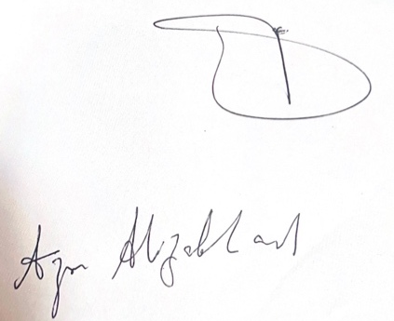

Office Use only

Decision | Reason | Signature of authorities | Date
Selected/Rejected

